

Saturday 28 February 2026
Skipton Town Hall
9.30am to 5.00pm
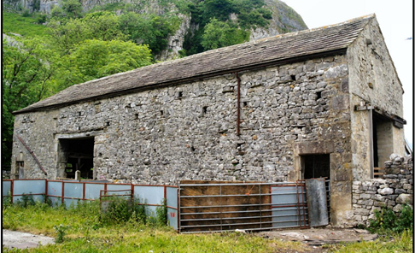
Our venue is the restored Concert Hall. Refreshment breaks and buffet lunch with vegan, vegetarian, dairy free and gluten-free options will be provided. There will be a book sale and information about the groups and their buildings study project.
Scar Laithe, Kilnsey Recorded by UWHG 2015
The talks will explore the variety of research work on the traditional buildings of the Dales. From the personal and observational approach of Marie Hartley and Joan Ingleby, to detailed building recording and interpretation, there are many ways to ‘see’ the buildings and the people.
Registration is from 9.30 and the day will start at 10.00. There will be refreshment breaks and a time for discussion at the end of the morning and afternoon sessions.
Talks (timings provisional)
10.15 Field Barns and Hogg Houses: Dales farm buildings and what they reveal Adam Menuge (University of Cambridge)
11.15 An introduction to the Skipton area and its buildings
Sue Wrathmell (Local historian)
1.30 Features of buildings in the Yorkshire Dales
Kevin Illingworth (Artist and photographer)
2.15 Vernacular buildings in the Yorkshire Dales: an archaeologist's perspective David Johnson (Archaeologist and author)
3.15 The development of the Dales buildings beyond 1700 as told by the evolution of Orms Gill Green at Airton Mark Womersley (Plaster conservator)
3.45 Cowside, Langstrothdale – Landmark Trust Repair and Conservation
Kate Holt, (Landmark Trust)

Saturday 28 February 2026

Day School Booking Form

Complete the form and tick the payment method
Return by 14 February 2026
If you wish to book after this date, phone/email to check availability of places.

Yorkshire Dales Day School - Saturday 28 February 2026

 | Members of YVBSG  and UWHG |  | Others |  | Students
 | Lunch | No lunch | Lunch | No lunch | No lunch
Price | £35 | £23 | £40 | £28 | £10
Number of tickets
Total Cost

☐ By Bank Transfer to YVBSG account number 52840000 Sort Code 09-01-56
For the transfer reference please use Day26 and your surname. Complete the booking form and email it to treasurer@yvbsg.org.uk with the message ‘I have paid by BACS’.

☐ By Cheque
I enclose a cheque payable to YVBSG
Post to David Cant, 3 Middle Hathershelf, Luddendenfoot, Halifax, HX2 6JQ

Enquiries to David Cant. Email davidjcant@hotmail.com or phone (01422) 883846.

Names(s) ___________________________________________________________________________________

Telephone/email_____________________________________________________________________________

☐ Please tick if you would like an acknowledgement
and add your email address or enclose an S.A.E.

