Bradford Area Follow-up Day
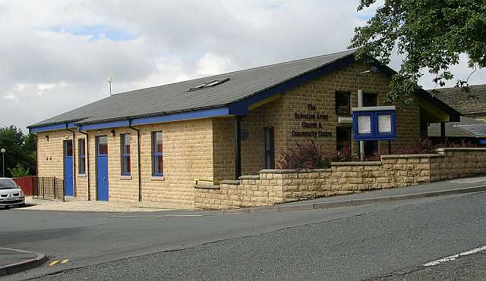
Saturday 18 October 2025

At the Wibsey Salvation Army Citadel, Holroyd Hill, Wibsey, Bradford, BD6 1NS

Programme
10.30 Refreshments and welcome
11.00 Presentations on buildings surveyed
13.00 Lunch – soup and roll, cake
14.00 Walk to look at historic buildings of Wibsey
16.00 Finish

Price including all refreshments: £10
Large on-site car park
Booking: Complete the form and return with payment by 11 October 2025 to
David Cant, 3 Middle Hathershelf, Halifax, HX2 6JQ
or email davidjcant@hotmail.com. Enquiries: 07749 676 974

BOOKING FORM
Please book _____ place(s) on the follow-up day
Payment: BACS ☐ or cheque ☐
payable to Yorkshire Vernacular Buildings Study Group
(sort code 09-01-56; account number 52840000)
Name: _________________________________________________________________
Contact (phone or email): _________________________________________________

